NAME………………………………………ADM NO: …………….CLASS……………

231/3

BIOLOGY PAPER 3 PRACTICAL

MARCH/APRIL 2023 TIME: 1 ¾ HOURS

MOKASA 1 JOINT EVALUATION EXAMINATIONS

*Kenya Certificate of Secondary Education*

231/3

BIOLOGY PAPER 3 PRACTICAL

MARCH/APRIL,2023 TIME: 1 ¾ HOURS

INSTRUCTIONS TO CANDIDATES

* Write your Name, Class and Adm No. in the spaces provided above
* Answer ALL the questions in the spaces provided

FOR EXAMINERS USE ONLY

|  |  |  |
| --- | --- | --- |
| QUESTION | MAXIMUM SCORE | CANDIDATES SCORE |
| 1 | 14 |  |
| 2 | 12 |  |
| 3 | 14 |  |
| TOTAL | 40 |  |

1. You are provided with a fruit labelled K. You are required to cut transversely through the middle section of the fruit using the knife provided. You are to use one half of the fruit for question 1 and preserve the other half for **question 2**.
   1. Cut a 1cm slice from one half of the fruit and remove the peel. Place the soft part of the fruit in a mortar and mash it into a fine paste using a pestle.

Add 10 ml of distilled water into the paste and stir the mixture, then transfer it into a beaker.

* 1. Using the reagents provided, carry out appropriate food tests on the mixture as you fill in the table below: (12 marks)

|  |  |  |  |
| --- | --- | --- | --- |
| Food  substance | Procedure | Observation | Conclusion |
|  |  |  |  |
|  |  |  |  |
|  |  |  |  |

* 1. Name the deficiency disease in children that may result from feeding them on specimen K alone especially after weaning. (1mk)

…………………………………………………………………………………………………..

* 1. Identify the hormone responsible for ripening of the specimen K above. (1mk)

…………………………………………………………………………………………………

1. Using specimen K and M provided;
   1. Identify the types of fruits and give reasons (4mks)

|  |  |
| --- | --- |
| Specimen | Reason |
| K |  |
| M |  |

* 1. State the mode of dispersal of specimen M and give a reason (2mks) Mode of dispersal……………………………………………………………………………… Reason…………………………………………………………………………………………

………………………………………………………………………………………………….

* 1. State and explain how fruit K is formed (2mks)

…………………………………………………………………………………………………

…………………………………………………………………………………………………

………………………………………………………………………………………………….

* 1. Draw and label fruit M (3mks)
  2. When a piece of specimen K was placed in hydrogen peroxide solution, bubbles were produced. State the physiological process that is similar to it in human that was being investigated (1mk)

…………………………………………………………………………………………..

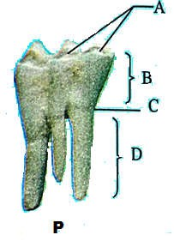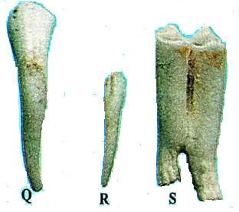3.(A)You are provided with photographs of specimens labeled P, Q, R and S which were obtainedfrom the same animal. Examine them and answer the questions that follow.

* + 1. With a reason identify P and Q. (4mks)

P *……………………………………………………*…………………………… Reason …………………………………………………………………………..

Q ………………………………………………………………………………... Reason …………………………………………………………………………..

* + 1. Using observable features only state.
       1. One similarity between specimen Q and R. (1mark)

……………………………………………………………………………………

……………………………………………………………………………………

* + - 1. One difference between specimen R and S. (1mark)

|  |  |
| --- | --- |
| **R** | **S** |
|  |  |
|  |  |

* + - 1. Explain how specimen S is adapted for its functions. (1mks)

……………………………………………………………………………………………

……………………………………………………………………………………………

…………………………………………………………………………………………… (c)In specimen P name the four parts labeled. (2mks)

A ………………………………………………………………..

B ………………………………………………………………..

1. 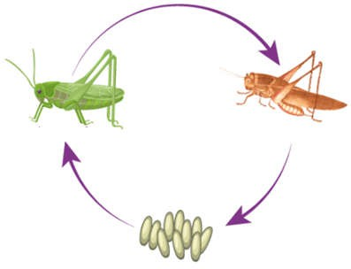The diagram below shows a process that takes place in some insects.Study it and answer the questions that follow.
   1. Identify the life cycle above (1mk)

………………………………………………………………………………

* 1. Name two hormones that control the process (2mks)

………………………………………………………………………………

………………………………………………………………………………..

* 1. Explain the importance of the process to organisms where it occurs? (2mks)

………………………………………………………………………………………

………………………………………………………………………………………

………………………………………………………………………………………

………………………………………………………………………………………

.